ECE516 Syllabus 2025

Intelligent Image Processing

Fundamentals of Intelligent Sensing, Meta-Sensing, and Image Processing for HuMachine Learning, Wearable AI, VR/AR/XR/XI (eXtended Reality + eXtended Intelligence), Autonomous Electric Vehicles, Smart Cities, etc.

Winter 2025, 39 lec., starts Jan7 + 5 labs + final project.
Website: http://wearcam.org/ece516/

Instructor: Professor Steve Mann (mann@eyetap.org), http://wearcam.org/bio.htm
TAs: Ali Barzegar Khanghah <alibarzegarkhanghah@gmail.com>
Nishant Kumar <nishant.kumar@mail.utoronto.ca>

Advisors: Arkin Ai (VisionerTech Founder), Raymond Lo (Meta Co-Founder), Chris Aimone (InteraXon CTO and Co-Founder), Ken Nickerson (Kobo Co-Founder), Ajay Agrawal (Rotman CDL Founder), Ryan Janzen (Transpod Co-Founder raised $550 million), Nahum Gershon (Father of Human-Information Interaction), and many others.

Time/Location:
- Tue. 1pm lecture;
- Wed. 1pm lecture;
- Fri. 9am lab only on certain Fridays as specified in wearcam.org/ece516/sched.htm
- Fri. 1pm lecture;
- In the event of a return of the pandemic, http://meet.jit.si/ECE516

Office Hours: At University of Toronto after every lecture, plus Saturdays
1:30pm to 3:30pm at the Firepit of Trillium Park, Ontario Place.

Purpose:

This course is designed to 1) provide instruction and mentorship to students interested in the art and science of understanding the world around us through HuMachine Learning, Wearable AI, XR/XI (eXtended Reality/eXtended Intelligence), intelligent sensing and meta-sensing, with an emphasis on intelligent imaging (e.g. computer vision with cameras, sonar, radar, lidar, etc.), and 2) teach the fundamentals of Human/Machine Learning in order to benefit humanity at multiple physical scales from “wearables” (wearable computing), to smart cars, smart buildings, smart beaches, (WaterHCI), and smart cities.

The emphasis is on fundamentally understanding technology in basic and simple ways through mathematics, physics, and actually building very simple AI, human-machine learning systems, and devices from first-principles, to develop a deeper understanding than is possible through merely using existing tools in a shallow way.

The primary course deliverable consists of labs which are demonstrations (i.e. for you to show your understanding of the material), plus hands-on mentorship.

You will learn the fundamental mathematics of, physics of, and how to build your own simple camera, photoquantigraphic image sensors, meta-sensors, metaverses, and XR/XI.

You will be learning fundamental new concepts such as panoramic HDR machine vision cameras and radar/sonar systems invented by the instructor, giving you a deeper understanding to enable you to invent new technologies. It is therefore expected that many students will go on to form startup ventures or graduate level research at MIT, Stanford, Silicon Valley, etc., around their prototypes and labs, through ongoing guidance and support.

Guest lecturers and mentors include founders, CEOs, and CTOs from venture-capital backed companies in the U.S., Canada, and China, many of which were founded in Professor Mann’s Toronto lab, as well as connections with Mannlab Silicon Valley and Mannlab Shenzhen where many of Prof. Mann’s inventions such as HDR imaging, chirplet-based radar vision, and metavision (predecessor of the metaverse), are being commercialized.

Overall Course Philosophy, Aims and Outcomes:

In this course you will begin by learning how to build your own camera, and your own photoquantigraphic image sensor, and also how to make your own computer vision systems. The emphasis of this course is to teach fundamental physical sciences and engineering so that you can learn how to think (and do) for yourself and thus invent new technologies.

Many universities have become tax-free hedge funds to serve the interests of big corporations and big government. They train students to become a source of cheap labour for big pharma, big data, big science, and big watching (surveillance). They train students to become a small specialized cog in a big machine. Many courses are no longer taught by professors who are authors of the textbooks or who are authorities on the subject matter, or who even show up to the labs to work directly with the students.

Therefore, what we aim to do in this course is restore the balance in favour of the student, i.e. to empower the student with concepts like "little data" (distributed data like blockchain), "little watching" (also known as sousveillance), and human-in-the-loop AI ("HuMachine Learning") [Minsky, Kurzweil, Mann, 2013], Wearable AI (IEEE Intelligent Systems), XI = eXtended Intelligence (IEEE CXI), XR = eXtended Reality.

In this course you will learn how to think for yourself and how to build things yourself so that when you graduate, you will know how to make things without requiring the support of lab technicians and massive infrastructure. These are the skills that startups as well as the top companies are looking for, and the skills you need to create your own startup.

See http://wearcam.org/ece516/philosophy.htm for more on the philosophy of ECE516.

III. Specific Learning and Evaluational Outcomes:

By the end of this course, students will:

      - Know the fundamentals of how cameras work, how to design and build cameras, and other imaging systems. Know the fundamentals of how radar vision works (e.g. Simon Haykin’s concept of radar capable of cognition), how to invent, design, and build new kinds of radar, sonar, and lidar systems, such as a computer vision system for the blind, or a system for a self-driving car, smart cities, metaverse, XR/XI, and beyond;

      - Understand fundamentals of personal technologies such as a small electric vehicle (e.g. mobility scooter) and fundamentals of sensing and meta-sensing associated with wearables and personal vehicles;

      - Deeply understand Human/Machine Learning in the Minsky, Kurzweil, Mann [2013] sense, i.e. Sensory HuMachine Learning, along with associated mathematical transforms, i.e. Comparametric Equations, and Adaptive Chirplet Transform and Intelligent Signal Processing (e.g. to fulfill Simon Haykin’s concept of vision systems capable of cognition).

Students will learn how to quickly turn ideas into inventions through a range of time-scales ranging from quick and sloppy “rapid prototyping” (rapid reduction-to-practice) to more well-made (longer time scale) prototypes designed for demonstration to others. Whereas other engineering courses often teach a slower more methodological approach akin to classical music, in this course, students will also learn “tinquiry™” (tinkering as inquiry), more akin to jazz music (i.e.. quick improvisation, often making working prototypes to turn ideas into inventions in 90 minutes or less). Formal large lectures will be given, but there will be ample one-on-one and small-group mentorship and meta-mentorship as well. For meta-mentorship, we offer to help you bring in friends and associates of your own, who you are comfortable with already, as co-mentors.

The course will use the Instructables.com website to help in teaching. The course instructor devotes a lot of time to individual one-on-one mentorship of students, and will respond individually to each “I made it” post on the Instructables.com site. Completing one or more of these Instructables will give students the opportunity to demonstrate aptitude for making things, and to get a sense of what kinds of topics the course instructor is best equipped to help you with. See https://www.instructables.com/member/SteveMann/instructables/

IV. Course Readings:

The course textbook is “Intelligent Image Processing” by Steve Mann, published by John Wiley and Sons, and available in the University of Toronto bookstore or on Amazon.

Additional readings, articles and publications are available online as well as XR/XI and Metavision content that will also be made available.

From time-to-time additional readings and instructables will be posted on http://wearcam.org and http://www.instructables.com/member/SteveMann/instructables/.

V. Course Evaluation and Grading Procedures, which are tentative due to possible new pandemic response changes to COFM (Composition of Final Mark):

COFM in relation to the regulations:
- Closely Supervised Individual Term Work: 15% (in-lab reports, testing, participation, etc.);
- Not Closely Supervised Work: 50% (take-home assignment or the portion of lab reports done at home, but all to be presented in the lab!);
- Final exam (or, due to a new pandemic, may shift toward an at-home exam, project or report): 35%, open-book.
Total = 100%

The non-exam portion above COFM (65%) is split among 5 labs, 1 final project (Symposium), assignment, with flexibility for students who choose to replace some or all of their labs with work on their final project (e.g. those who want to get an early start).

COFM in relation to the student deliverables:
- Each lab is worth 8% (4% presentation, 4% submission), for a total of 5*8% = 40%
- The introductory assignment (XR summary) = 2% rough point-form list or sketch of key points due Jan 24 + 3% to complete the summary by Feb. 6th = 5%
- Final project / Symposium = 5% submission + 15% presentation = 20%
- Final exam = 35%
Total = 100%

If you do something above and beyond what’s required, we also often award bonus points so that you can get more than 100%, but the mark will be clipped at 100% when submitted, since the final grade cannot be more than 100%. Internally we’ll keep a tally, so you can feel proud of your actual mark if more than 100% (and I can write that in a letter of reference or recommendation).

There is no midterm exam.

Late policy: if not agreed upon, it is 10%/day linearly, down to 0 in 10 days.

Lab periods are for grading. It is presumed that you will arrive at the lab with a working assignment to show and be graded in the lab (i.e. the prelab is to get it working and the lab is for you to show what you have done), and then there will be additional hands-on training.

Submissions will be made to Quercus as PDF with links to Instructables for the pictures and videos, and links to Gitlab for the code.

VI. Labs:

The majority of your grade comes from the labs, and the lectures are primarily in service of the labs.

Lab periods are for you to show your work and for you to connect with the professor and TAs and other members of the class. This is your opportunity to show off and see and be seen in the world of Intelligent Image Processing, computer vision, AI, human-machine learning, smart technologies….

The most important part of this course is the labs, which offer authentic, direct mentorship with a
high degree of involvement from the professor and other leading experts in image sensing, meta-sensing, and human-machine learning.

There are 5 labs with projects in these four areas, followed by a sixth final project/Symposium:
- Phase-coherent detection for active computer vision:
  - Active vision systems (sonar, radar, lidar);
  - Sonar vision system for the blind using the amplifier;
  - Fourier transform, wavelet transform, and chirplet transform;
  - Machine learning for computer vision: Radar Vision and LEM neural network;
  - Biosignals and biosensing. In this lab, we will build an ultrasound system to image your own heart. [Analysis of Seismocardiographic Signals Using Polynomial Chirplet Transform...].
  - See and photograph sound waves, radio waves, and light waves using a lock-in amplifier.
- Passive vision: Many courses on computer vision fail to teach the fundamental concepts of what sensing is and does. We'll begin with fundamental principles by first exploring a 1-pixel camera and 1-pixel display, quantigraphic (quantifiable) sensing, and meta-sensing.
  - Begin with fundamental 1-pixel display;
  - Build your own 1-pixel camera;
  - Quantigraphic sensing: Comparametric Equations;
  - HDR (High Dynamic Range) sensing and meta-sensing;
  - Self-driving vehicles, sensing, and meta-sensing;
  - Phenomenological augmented reality with metaverse and Metavision (beyond metaverse);
- Autonomous vehicles: Understanding 3 phase motors and electric vehicles within the context of Intelligent Image Processing, sensing, sousveillant-systems, and metaveillance, metaveillogrammetry, and metaveillography;
- Tentative: a final project of your own choosing (time and student interest permitting)...

VII. Opportunities

Prof. Mann is widely known as the inventor of HDR (High Dynamic Range) imaging used in more than 2 billion smartphones, and in his role as a founding member of the IEEE Council on Extended Intelligence and the Chair of the Silicon Valley Investment and Entrepreneurship Forum, is well-connected to industry. There are many opportunities in Toronto, Silicon Valley, and Shenzhen China, for people who are well-grounded in fundamentals leading to deeply understanding wearable technologies, self-driving cars, smart cities, and HuMachine-Learning/Extended-Intelligence (HI) for wearables, autonomous vehicles and smart cities. Ford Motor Company is collaborating with us and we’re looking for people for this as well. Prof. Mann has also helped a number of students get into MIT (his alma mater) and Stanford (where he spent a lot of time living and working).

Doing really well in this course is your chance to impress us and our advisory team and also to build a foundation and make and do things that will impress others. Many students have said that they’ve learned more in this course than all their other courses put together. Here’s your chance to “put your feet on the ground” and build a solid foundation under all of what you do.

Please see http://wearcam.org/ece516/opportunities.htm for summer and fall opportunities in MannLab.com as well as at the University of Toronto, MIT, Stanford, Ford Motor Company, etc.

VIII. Academic Integrity

Each student in this course is expected to abide by the University of Toronto Code of Behaviour on Academic Matters. Any work submitted by a student in this course for academic credit will be the student's own work.

You are encouraged to study together and to discuss information and concepts covered in lecture and the sections with other students. You can give "consulting" help to other students or receive "consulting" help from such students. However, this permissible cooperation should never involve one student having possession of a copy of all or part of the work done by someone else, in any form (i.e. mail, digital file, floppy disk, audio recording, or a hard copy).

Should copying occur, both the student who copied work from another student and the student who gave material to be copied will both automatically receive a zero for the assignment. Penalty for violation of this Code can also be extended to include failure of the course and University disciplinary action.

During examinations, you must do your own work. Talking or discussion is not permitted during the examinations, nor may you compare papers, copy from others, or collaborate in any way. Any collaborative behavior during the examinations will result in failure of the exam, and may lead to failure of the course and University disciplinary action.

IX. Accommodations for Students with Disabilities

In compliance with the University of Toronto policy and equal access laws, I am available to discuss appropriate academic accommodations that may be required for students with disabilities. Requests for academic accommodations are to be made during the first three weeks of the semester, except for unusual circumstances, so arrangements can be made. Students are encouraged to register with Student Disability Services to verify their eligibility for appropriate accommodations.

We are also extremely well-versed in seeing aids for the visually impaired, as well as in electric mobility aids.

X. Notice of video recording and sharing

At times during this course, some interactions including your participation might be recorded on video and will be available for remote viewing and after each session. Course videos and materials belong to the instructor and/or other source depending on the specific facts of the various situations and are possibly protected by copyright or copyleft. In this course, you are permitted to download session videos and materials for your own academic use, but you should not copy, share, or use them for any other purpose without the explicit permission of the instructor. For questions about recording and use of videos in which you appear please contact your instructor. We are generally happy to support widespread learning and teaching and service to the community, and we are generally in favour of copyleft + GPL (GNU Public License) as guiding principles. Feel free to discuss with the instructor or TAs (Teaching Assistants).

XI. Land + Water + Air Acknowledgement

I (we) wish to acknowledge this land, waterways, and air space in which the University of Toronto operates, as well as the space at Ontario Place where our outdoor “TeachBeach™” is located. For thousands of years these places have been traditional places of the Huron-Wendat, the Seneca, and most recently, the Mississaugas of the Credit River. Today, these meeting places are still the home to many Indigenous people from across Turtle Island and we are grateful to have the opportunity to work here.

XII. Cyberspace and Cyborgspace Acknowledgement

I (we) wish to acknowledge the work of many great minds before us, and our responsibility to the ethical principle of openscience and free-open-source (FOS) computation, and the like. Traditionally computer programming was a free and open space, and we aim to keep it free and open. Consistent with these ethical principles, we will favour FOS programs such as Jitsi, GNU Linux, Inkscape, GIMP, Octave, and the like.
We embrace Mersivity, and we pledge to advance technology for humanity and earth, and in particular, we regard technology as a vessel that should connect us to each other and to our surroundings (the environment) as outlined at https://Mersivity.com
To better understand this Acknowledgement, take a look at an installation of the San Francisco Art Institute and elsewhere, http://www.wearcam.org/seatsale/

XIII. Inclusivity Statement

We understand that our members represent a rich variety of backgrounds, perspectives, and health conditions.

Everyone at University of Toronto has the right to a safe, welcoming, respectful, and inclusive in/en/vironment. In this class we are all responsible for our language, action and interactions. Discriminatory comments or actions of any kind will not be permitted. This includes any form of discrimination based on physical or mental state or attributes, health conditions, medical status, medication, or the lack thereof.

If you experience or witness any form of discrimination, please contact IDEA (Inclusion, Diversity, and Equity, Advisory Committee) or any faculty or staff member you feel comfortable approaching.

The engineering department is committed to providing an atmosphere for learning that respects diversity. While working together to build this community we ask all members to:

  - Share their unique experiences, values and beliefs
  - Be open to the views of others
  - Honor the uniqueness of their colleagues
  - Appreciate the opportunity that we have to learn from each other in this community
  - Value each other’s opinions and communicate in a respectful manner
  - Keep confidential discussions that the community has of a personal or professional nature
  - Use this opportunity together to discuss ways in which we can create an inclusive environment in this course and across the university community

XIV. Accommodations

If you have a learning need requiring an accommodation, University of Toronto recommends that students immediately register at Accessibility Services at www.studentlife.utoronto.ca/as.
Location: 4th floor of 455 Spadina Avenue, Suite 400
Voice: 416-978-8060
Fax: 416-978-5729
Email: accessibility.services@utoronto.ca

The University of Toronto supports accommodations of students with special learning needs, which may be associated with learning disabilities, mobility impairments, functional/fine motor disabilities, acquired brain injuries, blindness and low vision, chronic health conditions, addictions, deafness and hearing loss, psychiatric disabilities, communication disorders and/or temporary disabilities, such as fractures and severe sprains, recovery from an operation, serious infections or pregnancy complications.

XV. Mental Health:

As a university student, you may experience a range of health and/or mental health issues that may result in significant barriers to achieving your personal and academic goals. The University of Toronto offers a wide range of free and confidential services and programs that may be able to assist you. We encourage you to seek out these resources early and often.

If, at some point during the year, you find yourself feeling distressed and in need of more immediate support, visit the Feeling Distressed Webpage: www.studentlife.utoronto.ca/feeling-distressed, for more campus resources.

Off campus, immediate help is available 24/7 through Good2Talk, a post-secondary student helpline at 1-866-925-5454.

Appendix. Available Course Equipment

VisionerTech VMG-PROV

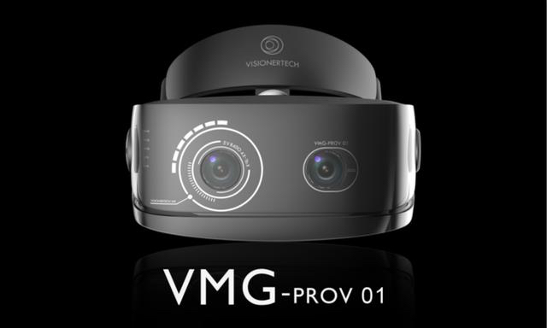

Related link: https://www.youtube.com/watch?v=T0m0qGA8xhk

Meta Augmented Reality Eyeglasses (Meta, Meta 2, and Meta Pro available)
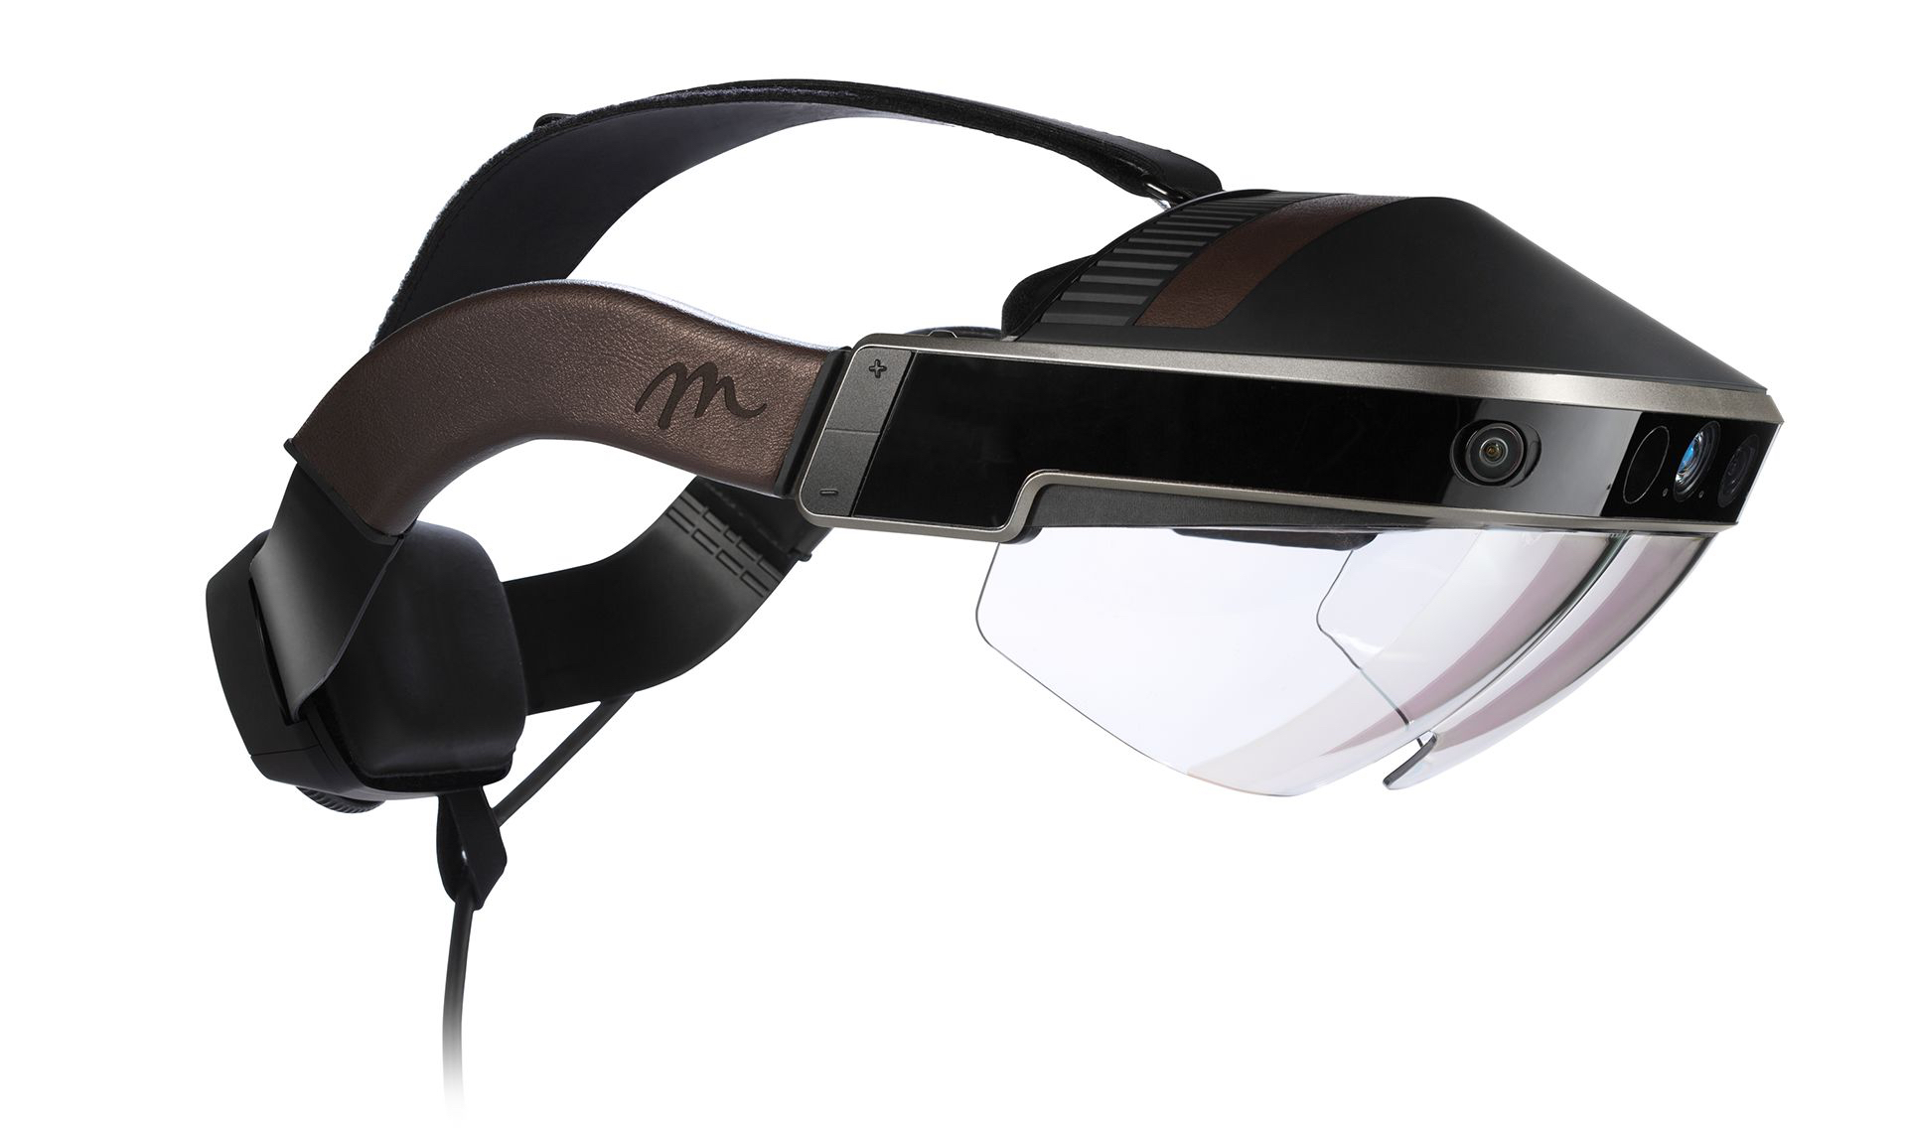

Related link: http://www.wearcam.org/meta.htm

Muse Headband
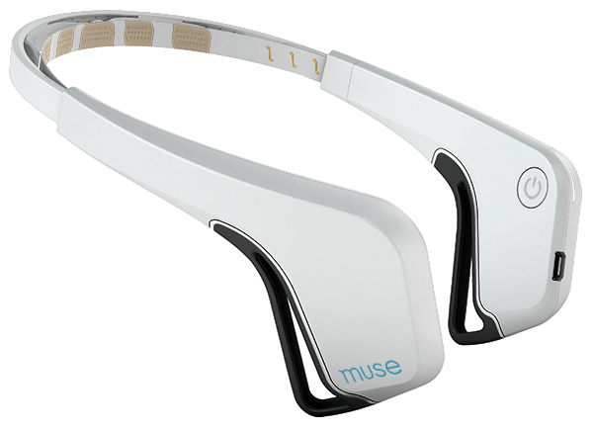

Related link: https://www.choosemuse.com

Muse Safilo Eyeglasses
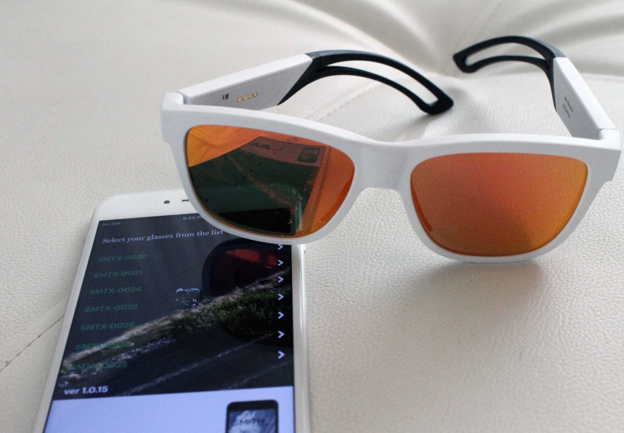

Related link:https://www.youtube.com/watch?v=5CZtoYbfbHU

Vuzix Blade augmented reality / X-Reality eyeglass (runs Android OS)
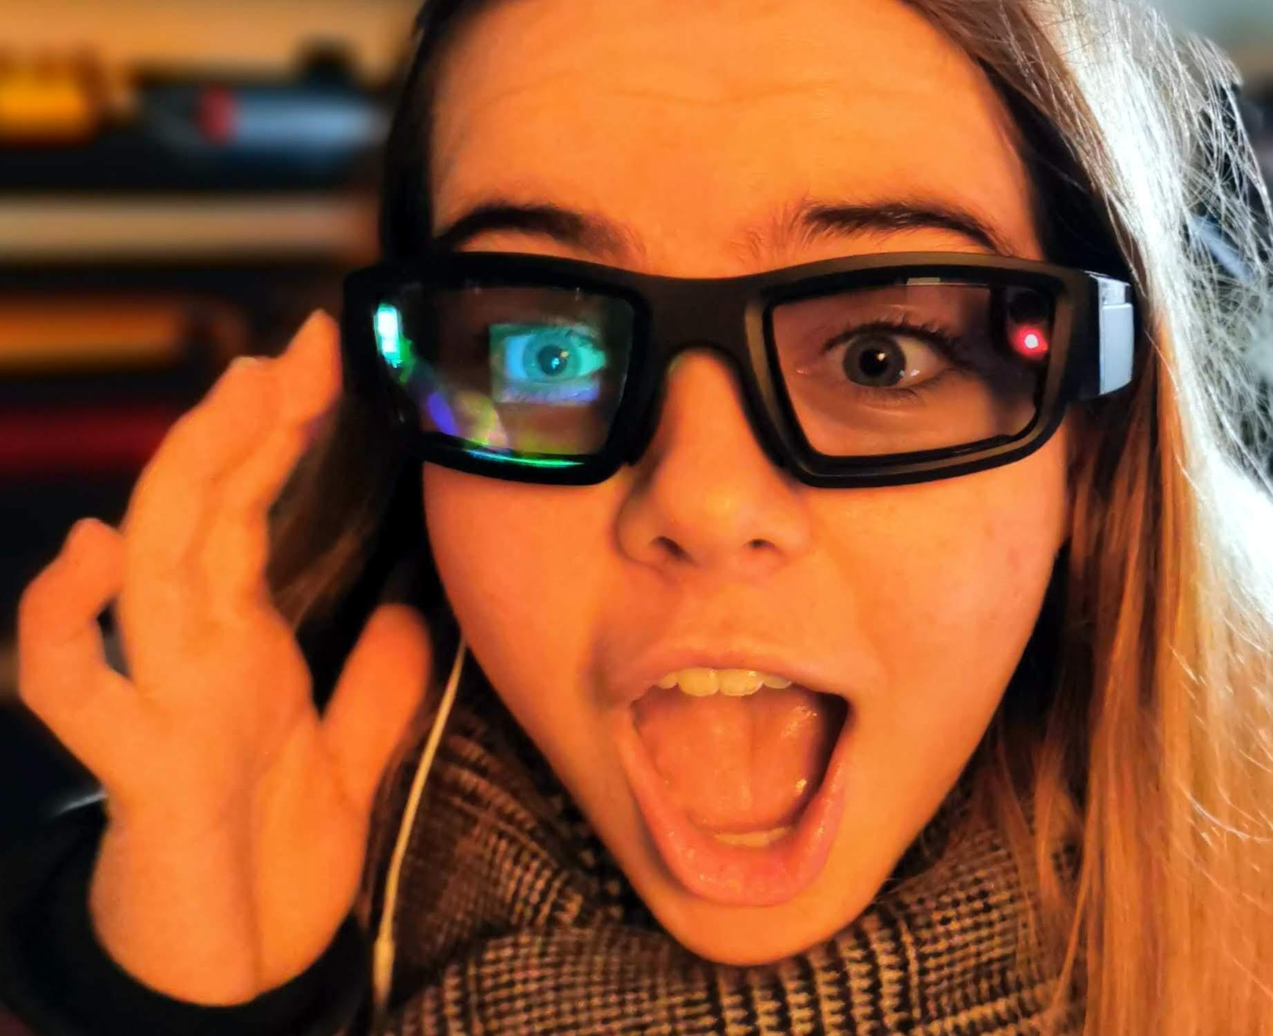

SmartSwim (Android OS) for underwater augmented/eXtended Reality,
Heart monitoring during icewater swim, mapping of water conditions, obstacle avoidance, ice flow, etc..
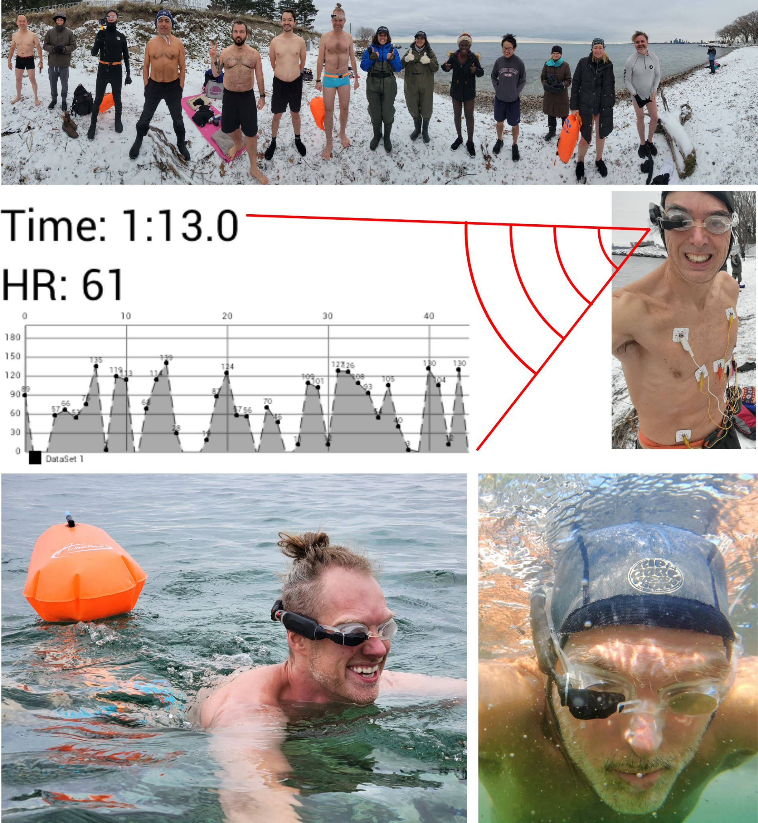

Metaveillance SWIM (example: Blueberry world+brain-sensing eyeglass)
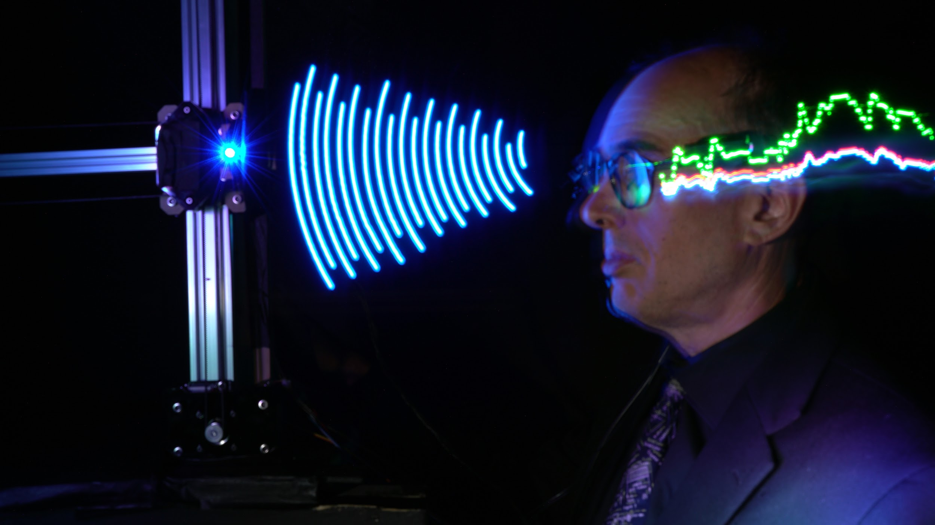

Open EyeTap (multi-exposure photograph with SWIM)
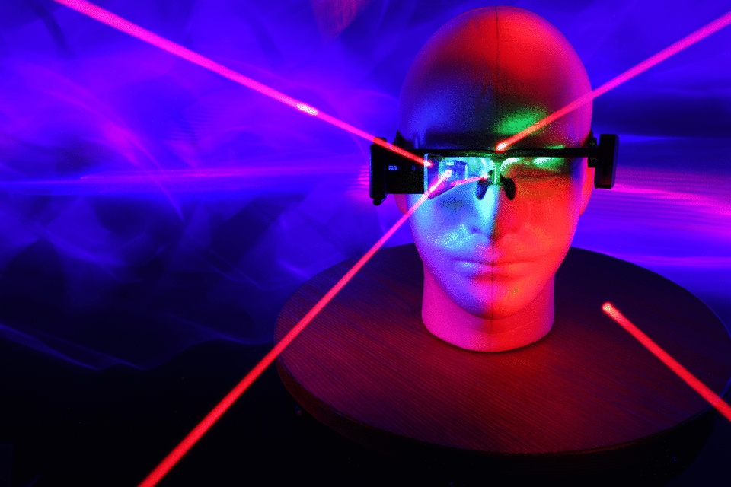

Related link: https://www.openeyetap.com

“MannLab x SYSU” Lock In Amplifier & Phenomenological Augmented Reality
We have a large collection of lock-in amplifiers including the best in the world, PAR124A SR510, and MannLab x SYSU SO1024 Scientific Outstrument™.

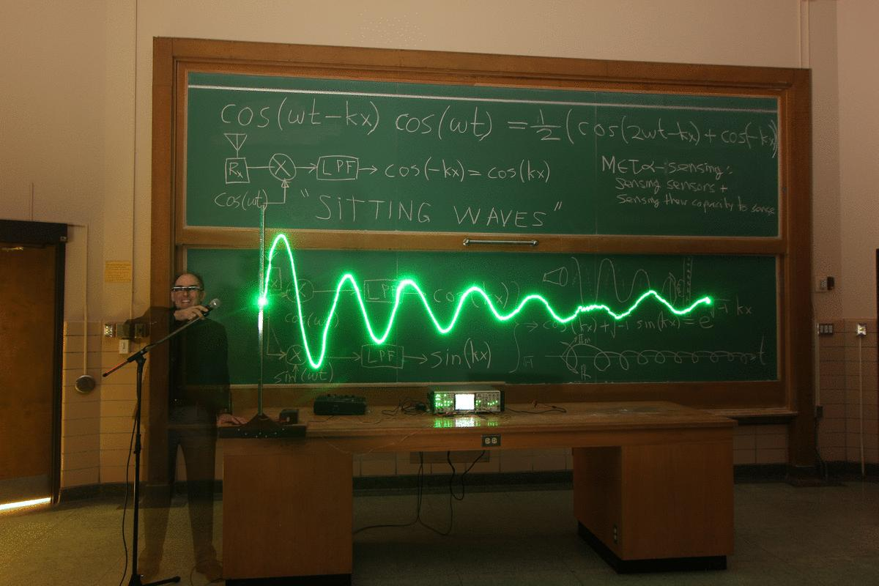

Related link: http://www.wearcam.org/par/

HTC Vive with Lighthouses

Underwater wearable camera system

Insta360 X3

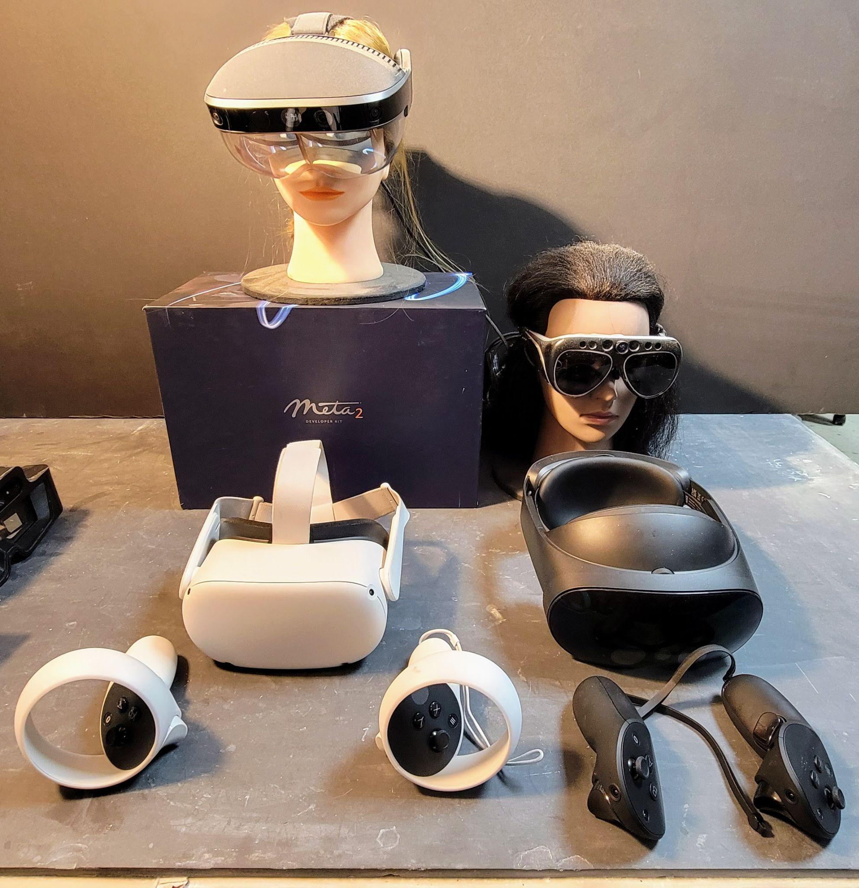
Left-to-right:
Back row: Meta 2 and Meta Pro (2016), built by Meta (co-founded by Steve Mann).
Front row: Meta Quest 2 and Meta Quest Pro (2022)

