
CNIB’s Innovative OUTDOOR CLASSROOM Project
Calgary, Alberta

What started out as a request to paint our fence at a United Way Day of Caring in 2005, became a project that we could not have imagined. Just by chance, the company helping that day was an urban design company who has a strong belief in volunteering. After years of planning, designing, fundraising and collaborating with local businesses and agencies, the CNIB Outdoor Classroom was officially unveiled at the Calgary centre’s annual community event in October 2008.

The Outdoor Classroom Project has been and continues to be an opportunity for CNIB to create:
- a LEARNING ENVIRONMENT for children with vision loss.
- COLLABORATION and PARTNERSHIPS with businesses and organizations in the community.
- COMMUNITY IMPACT on the awareness of the unique needs of people with vision loss
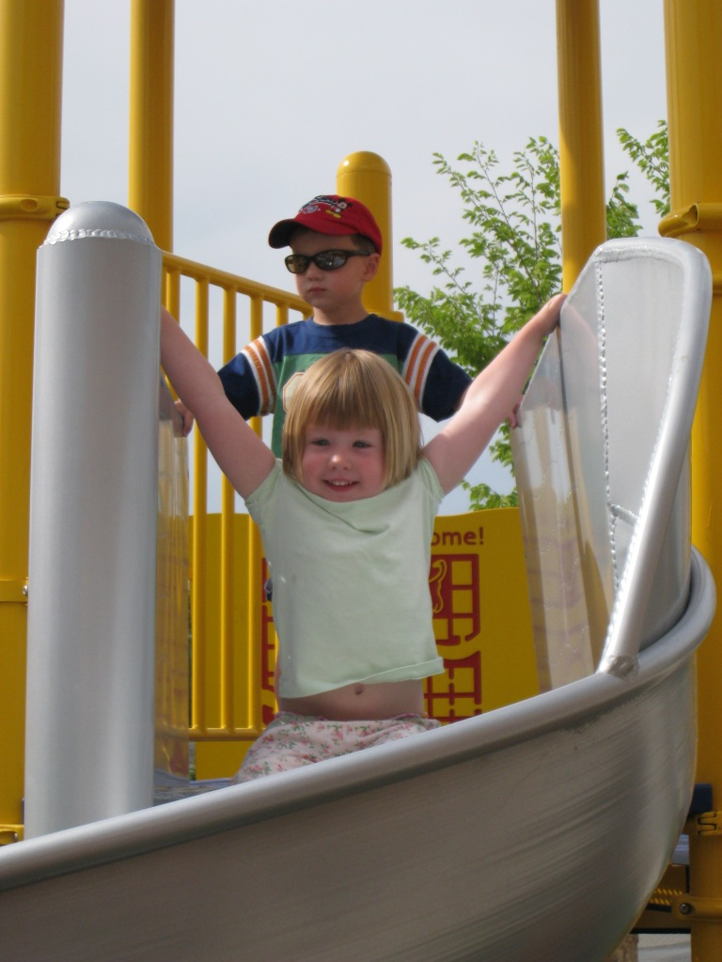
LEARNING ENVIRONMENT

A concern that we often did not have the space to work on early orientation and mobility and gross motor skills made us re-evaluate how the space we had could be better utilized. We also wanted it to be a place where children could explore as independently as possible from an early age.
When we did the initial research we were inspired by an outdoor play space at the Western Pennsylvania School for the Blind in Pittsburgh. They generously sent a DVD that oriented us to the space and showed how this space was used to work on skills that are important for children with vision loss. With these things in mind we started to envision what our space could look like. There were many revisions to the plan as we worked closely with our design team. The materials, space, land restrictions, ongoing maintenance, along with all of the features that would make it an ideal learning environment for children needed to be considered. The final result is an outdoor play space where children with vision loss can explore, develop skills and build confidence in a safe and interactive environment.

COMPONENTS and DESIGN

Sensory Components:
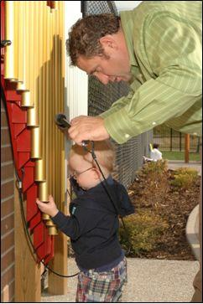
Hearing: musical bench, xylophones, and hydraulophone, drum, chimes, horns
Sight: high contrast colours, limited pattern, space between elements, shaded areas for children who are light sensitive and bright areas for children who see with optimal lighting, shiny metal slides and xylophone.
Touch: tactile map, tic tac toe, different textured surfaces: rubber, different types of concrete, metal, plastic, grass, shrubbery, water, wooden bench and bridge, leaves, snow, Braille and shape of the hydaulophone.
Smell: Nearby fragrant garden, rubber, rain, fragrances of the outdoors
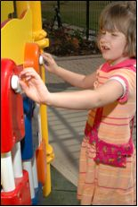
Vestibular: linear – walking/running, bouncing plane, vibration of xylophone, slides – spiral and straight.

Skill Development
There are many ways that this space is used to work on goals that address development skills. Examples include:
A great place to learn scanning techniques. Motor skills: Steps, space to run, bench for sitting or cruising, pronation and supination with car game (like knob turning). Grasp, release and hitting a target - holding mallet for xylophone.
Social skills: turn taking – two xylophone so one person can echo the other. Accessible games that promote interaction with peers

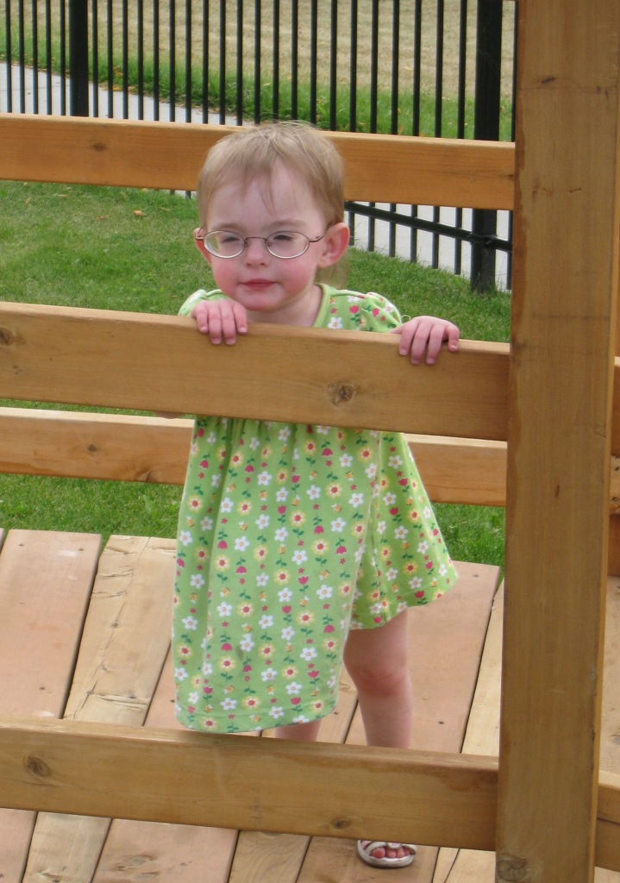
Orientation and Mobility
A looped pathway system helps children practice their cane and orientation skills. Walking surfaces include distinct textures to help the areas to be detectable with a cane including rubber tiles, for safety and good support, a wooden bridge, that ascends and descend, aggregate pavement, paving stones and tinted concrete.

The classroom is safe and accessible space for everyone at every age: Adjustable height platforms for the hydraulophone and space under tactile map and sand/water table accommodate wheelchairs and strollers. Playground equipment has no gaps to step through and cues to indicate where to sit for the slides. It also has a clearly defined perimeter. A tall, black wrought iron fence allows children to wander with no fear of walking into the nearby parking lot. There are also quiet corners for a break from the activities, rest and shade.
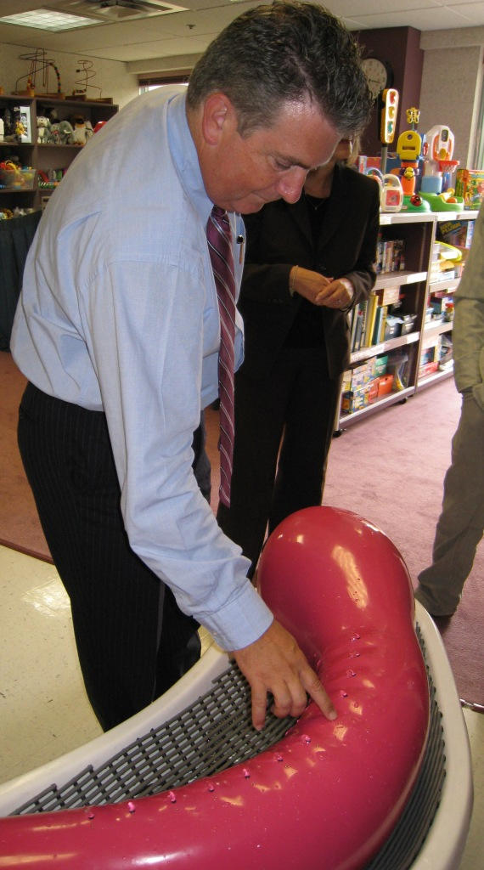
A unique component to the Outdoor Classroom, the Nessie water feature promotes the senses of touch and sound as part of a learning experience for children with disabilities. Invented by Dr. Steve Mann, a professor at the University of Toronto, the Nessie hydraulophone is a musical instrument similar to a woodwind instrument that uses pressurized water instead of air. These aquatic sculptures invite people not only to enjoy the look of these unique instruments but also to engage them in play. In the shape of a fun-loving lake monster, Nessie is enjoyed by curious children and adults. Soft sounds of music emerge as they running their palms over the instrument’s cool water jets and Braille labels. Collaborating with music therapists, CNIB’s Occupational Therapist enlists Nessie's help in working with clients. The fun and tactile nature of musical creation has made Nessie a popular among clients, their siblings, and others with physical and developmental challenges.

COLLABORATIONS and PARTNERSHIP

Four years ago, CNIB partnered with Urban Systems, a company that is dedicated to creating livable, efficient and innovative neighbourhoods and communities. Beyond the ability to provide high-quality, well-built infrastructure to our community, Urban Systems was looking for opportunities to make a significant difference in the lives of children and young people facing challenges. Together, Urban Systems and CNIB began examining how the area outside the Calgary centre could be improved to advance the programs offered through Children and Family Services. It was then that the Outdoor Classroom concept was born. From day one through final construction and unveiling, Urban Systems has been a dedicated partner, lending its expertise, manpower, labour, time and money into helping the Outdoor Classroom come to fruition.

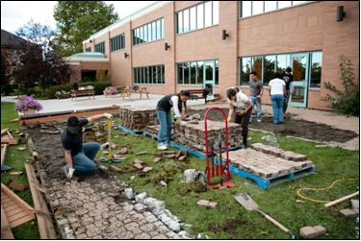
Shannon McQuillan, a representative working with the Urban Systems Foundation, said that the Foundation chose to support the Outdoor Classroom for a couple of reasons:

“..in part because of how [the project] aligns with our vision of helping kids who are facing challenges, but as well because of how it engaged the professional skills and personal passions of Urban Systems’ Calgary office staff. Clearly, staff wanted to be involved in the CNIB initiative and there was a strong determination on the part of the team to see the project through to completion. Furthermore, the Foundation board was confident in the clear and articulate vision for the Outdoor Classroom, and in the respectful and collaborative working relationship between the Calgary Foundation team and the staff of CNIB Calgary.”

Another key partnership in the project was established through CNIB’s existing relationship with local WestJet officials. CNIB not only received financial support for the Outdoor Classroom from but also some valuable volunteer support during Phase II of construction. WestJet’s culture of caring was extended to CNIB with volunteers who were positive and passionate about any project tasks that they were given. They worked tirelessly over three days to assemble the play structure, permanently install the playground items, and complete the landscaping. The project was an opportunity to work with many businesses that had never supported CNIB before. For many of them it was their first introduction to the unique needs of children with vision loss. With support from over 15 donors, CNIB raised enough money to cover the cost of the Outdoor Classroom.

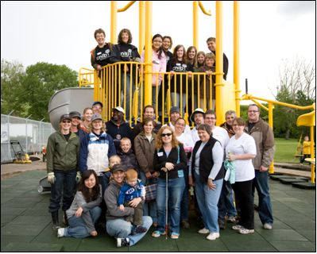

COMMUNITY IMPACT

This project as helped us to connect with many people in the community that we have never had the chance to be connected with before. On behalf of the Urban Systems Foundation, Shannon expressed:

“We hope that through our involvement in this project we have helped to strengthen and expand connections between business and non-profit communities. We hope that by providing opportunities for volunteering in the Outdoor Classroom that the staff of Urban Systems will be inspired to continue to give back to community groups. We hope that by seeing the Outdoor Classroom through to completion that children with vision loss will enjoy a better quality of life and that the public will come to have a better understanding of what it is like for children living with disabilities. Ultimately, our hope is that the support of the Urban Systems Foundation leads in some small way to a more compassionate, understanding and connected community.”

CNIB recently received funding from The Calgary Foundation for development of educational programs to be implemented in collaboration with local elementary schools. Students will not only learn about exploration through the senses but will gain an understanding about the abilities of children with vision loss.

It has been a challenge and a privilege to be a part of this project from inception to completion. If you would like more information about the Outdoor Classroom, please contact us.
The Outdoor Classroom is available for use by other organizations helping children with disabilities.

Lara Anderson, B.Sc.O.T.(c)
Occupational Therapist
Early Intervention Program
Calgary CNIB Office
15 Colonel Baker Place NE
Calgary, AB
T2E 4Z3
(403)261-7230
lara.anderson@cnib.ca

